www.shelfordfeast.co.uk

Application for a Feast Grant

With increasing demands on our funds we aim to make donation decisions based on information you give us, presented in a clear and straightforward way.

Our constitution aims:
“.. to further such charitable purposes as the Trustees in their absolute discretion may from time to time decide, including the advancement of education and other charitable purposes, for the benefit of the community of Great Shelford and neighbouring parishes, primarily but not exclusively by the provision of grants.”

The criteria for a grant from the Shelford Feast include (in no particular order):
- Being a local charity or non-profit-making organisation
- Financial need, especially where there is no alternative funding source
- Helping particularly the young, the old or the needy
- Where a contribution would make most significant impact
- Where there is a significant contribution to The Feast by the organisation or its supporters

Please complete the accompanying form and return to
Duncan Grey, 45 Hinton Way, Great Shelford Cambridge CB22 5AZ or
by email to info@shelfordfeast.co.uk
by September 30th.

Please note that receipt or completion of this form does not imply that any grant will be given. Funds depend entirely on the profits, if any, from the annual Feast, which vary from year to year. The Bunch aims to be fair in allocating its funds. Its decisions are final.

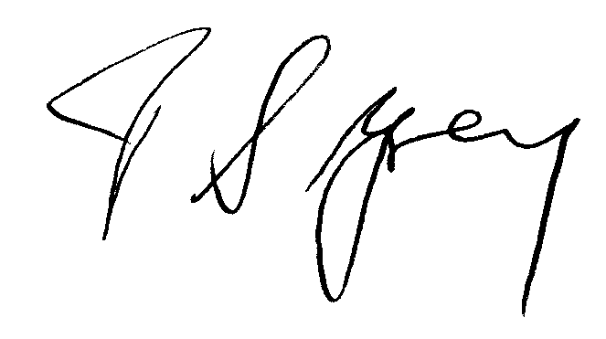

Duncan Grey, Secretary, The Shelford Feast.

Shelford Feast Grant Application

Organisation Name: …………………………………………………………………..

Contact Name:

Address:

Your Role or Position:

Phone: Email:

Bank account into which grant should be paid:

Account no: Sort Code:

How does your request meet the Feast Grant Criteria? (see accompanying letter)

Brief description of how you have used past grants (if any)

How you would use a grant if you were fortunate enough to receive it?
(Please be as specific as possible)

Additional information (if any) may be added if you wish

